NEIGHBORHOOD WATCH ALERT SYSTEM
@CREATIVITY THINK (9483175986/7019689991)

ABSTRACT:
Neighborhood Watch Alert System is a web-based platform designed to enhance community safety in gated communities, apartments, and villages. The system enables residents to post alerts categorized as suspicious, emergency, or informational, along with location tags, photos, and descriptions. Neighbors can view alerts on a feed or interactive map, comment, update status, and track historical alerts. Administrators moderate alerts, verify emergencies, assign tasks to security staff, and monitor safety trends using dashboards. Built with Django and Django REST Framework for backend operations, and React with Leaflet, axios, and interactive dashboards on the frontend, the platform ensures timely alert dissemination, structured tracking, and community engagement..

INTRODUCTION OF THE PROJECT:
Safety and security are critical concerns in residential communities. Traditional methods of alerting neighbors, such as word-of-mouth or printed notices, are slow and unorganized. Neighborhood Watch Alert System addresses these limitations by providing a centralized, digital platform for real-time alerts, location tagging, and community engagement. The system facilitates quick dissemination of critical information, allows residents to report suspicious activity, and helps administrators manage security incidents efficiently, promoting safer neighborhoods..

PROJECT OBJECTIVES:

• Provide a platform for residents to post alerts with category, description, photo, and location
• Allow neighbors to view alerts on feed and interactive maps
• Enable users to comment, update, and mark alerts as resolved
• Maintain a historical record of alerts for transparency and tracking
• Facilitate administrative moderation and verification of alerts
• Assign incidents to security staff and monitor their resolution
• Provide dashboards with heatmaps, statistics, and trends
• Send broadcast safety tips to residents
• Export incident reports for administrative and legal purposes

PROBLEM OF THE STATEMENT:
Residential communities often face delayed or unstructured communication regarding safety issues. Residents cannot efficiently report suspicious or emergency events, and administrators lack tools for monitoring, verifying, and assigning tasks for incidents. Manual or informal methods fail to provide a historical record, community engagement, or analytics for decision-making. Neighborhood Watch Alert System solves these problems by offering a structured digital platform for real-time alert posting, verification, tracking, and analytics..

MOTIVATION OF THE PROJECT:
• To provide timely and structured alert dissemination for community safety
• To engage residents in proactive reporting of suspicious activities
• To reduce manual communication delays and inefficiencies
• To track and resolve incidents systematically with administrative oversight
• To generate actionable insights through dashboards and heatmaps
• To enhance transparency and accountability in neighborhood security
• To facilitate broadcast communication for safety awareness
• To maintain historical records for trend analysis and reporting

BLOCK DAIGRAM OF PROJECT:

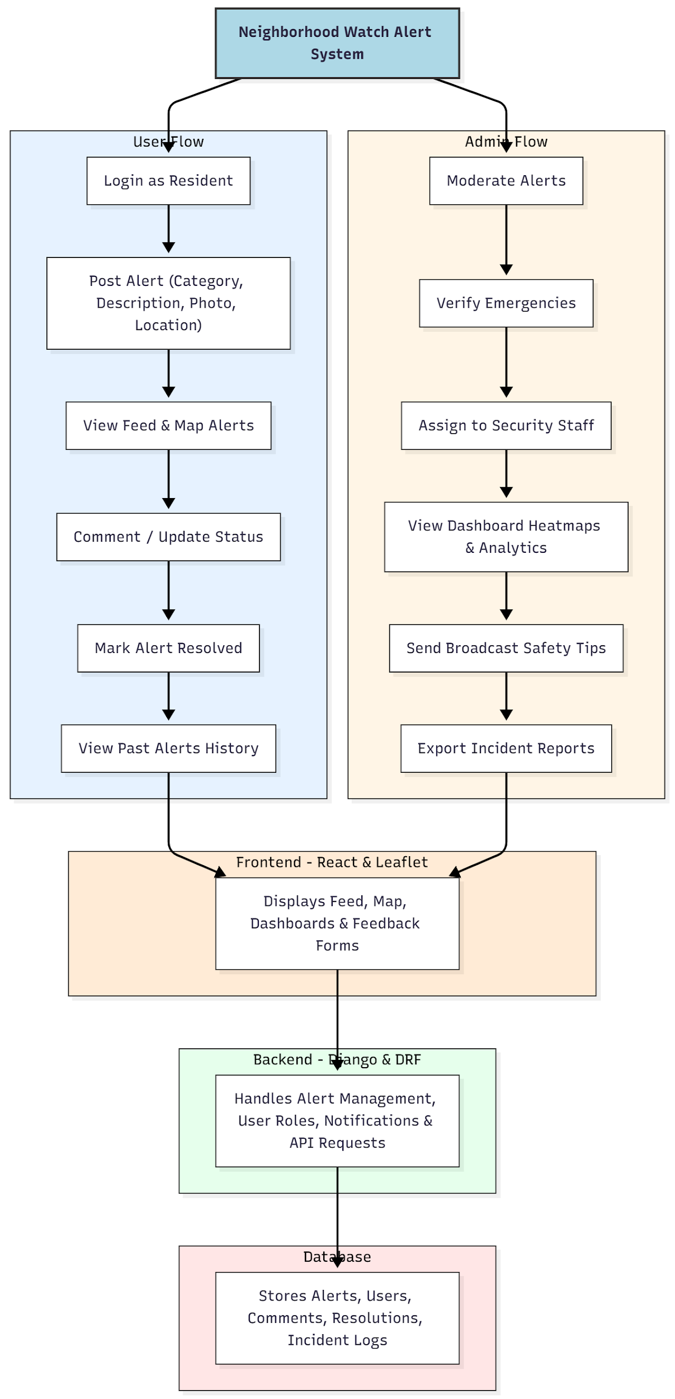

WORKING OF THE PROJECT:
Residents log in and post alerts specifying the category, description, photo, and location. Alerts are immediately visible on the feed and interactive map for neighbors. Users can comment, update status, and mark resolved alerts. Administrators moderate incoming alerts, verify emergency situations, assign tasks to security personnel, and monitor all activity via dashboards. Heatmaps and analytics provide insights into incident trends, while broadcast messages keep the community informed. The backend handles user authentication, alert storage, notifications, and API requests, ensuring real-time updates and data integrity..

SOFTWARE REQUIREMENT:
- Backend:
  - Python 3.x
  - Django
  - Django REST Framework
  - SQLite/PostgreSQL
- Frontend:
  - Node.js and npm
  - React.js
  - Axios
- Development Tools:
  - Visual Studio Code
  - Postman (for testing APIs)
  - Git/GitHub (for version control)
- Server/Deployment (Optional):
  - Gunicorn, Nginx, or Heroku/AWS for hosting

ADVANTAGES OF THE PROJECT:

• Enables real-time alert posting and notifications
• Engages residents in proactive community safety
• Provides administrative moderation and task assignment
• Interactive maps and dashboards for monitoring incidents
• Maintains historical data for analysis and reporting
• Broadcasts safety tips to all community members
• Supports structured reporting and decision-making
• Enhances security, awareness, and accountability

APPLICATIONS OF THE PROJECT:
• Gated communities
• Apartment complexes
• Residential colonies
• Villages and rural safety initiatives
• Neighborhood watch programs

REFERENCES:

- Django REST Framework Documentation — Django Software Foundation. Django Documentation. Available: https://docs.djangoproject.com/
- Django REST Framework. DRF Documentation. Available: https://www.django-rest-framework.org/
- React. React Official Documentation. Available: https://reactjs.org/docs/getting-started.html
- Redux. Redux Documentation. Available: https://redux.js.org/introduction/getting-started
- PostgreSQL Global Development Group. PostgreSQL Documentation. Available: https://www.postgresql.org/docs/
- MySQL. MySQL Reference Manual. Available: https://dev.mysql.com/doc/
- Git. Git Documentation. Available: https://git-scm.com/doc
- Node.js. Node.js Documentation. Available: https://nodejs.org/en/docs/
- Axios. Axios Documentation. Available: https://axios-http.com/docs/intro
- Socket.io Documentation – https://socket.io/docs/

